Shanxi report from July to October 2014

- We had the honor to invite Professor Lee Chek Fun from University of Hong Kong
to inspect our plantation site, in Shanxi with Professor Lau Kao Woon from
Beijing (Chinese Academy of Science) in early October.

- Both professors showed interest and approval of our plantation work in Shek Lau
and agreed to make arrangement to set up a basic science research project to
document the changes before and after our plantation work. That would be a
great help to further spreading of our plantation work for others' reference.

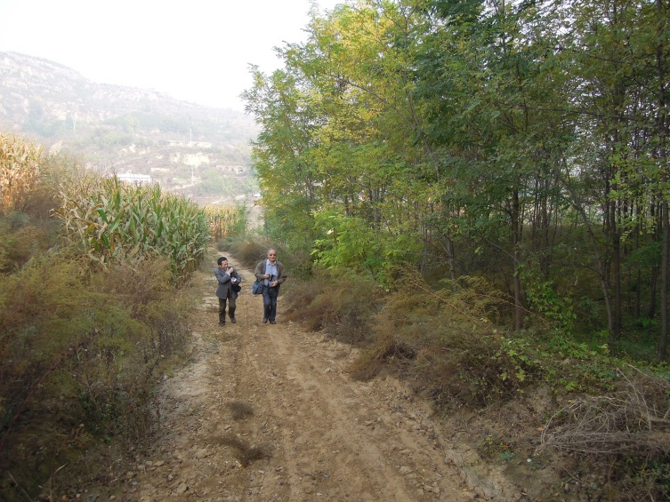 | 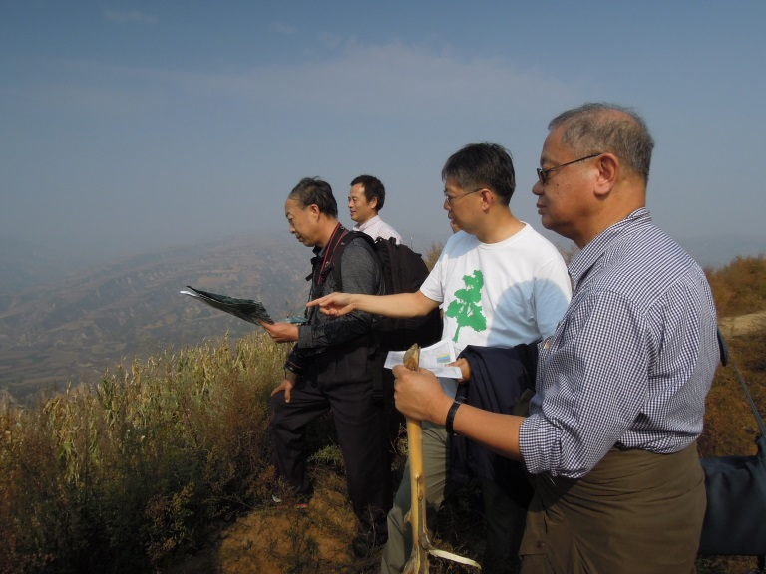

- According to Professor Lau's advice, we shall leave untouched 20 acres of our
farmland already rented as a comparison for future work. In the meantime we shall plant 50 acres of farm land with fruit trees for the economic gain of the local farmers.

- The plantation of the 50 acres of farmland was done and finished soon after we
transfered the money needed to Mr. Cheung Kim Kam. We shall see the result
next year.

- The trees were in stable condition during our last visit in October, the spring
water source had grown up to a small pond of the width of about 5 feet x 15 feet and with a depth of about 4-5 feet. We are planning to set up a small well and bringing out the water by pipeline for the use of the villagers. That would still depends on the actual needs and suggestion of the local villagers later.
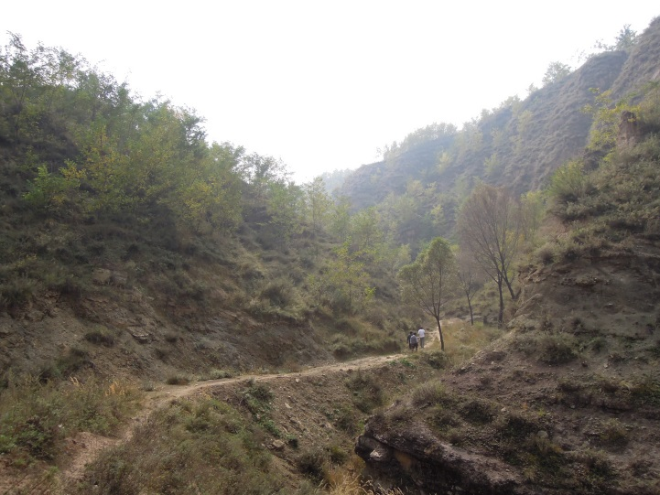 | 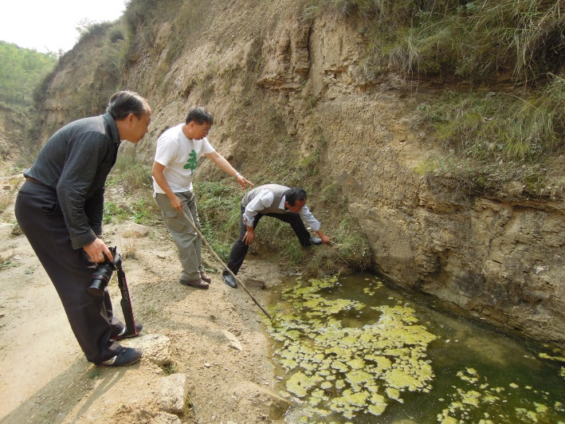

- We also visited Wong Man Ling in October and chatted with local farmer Fong
Kam Hoi and the trees condition are stable.

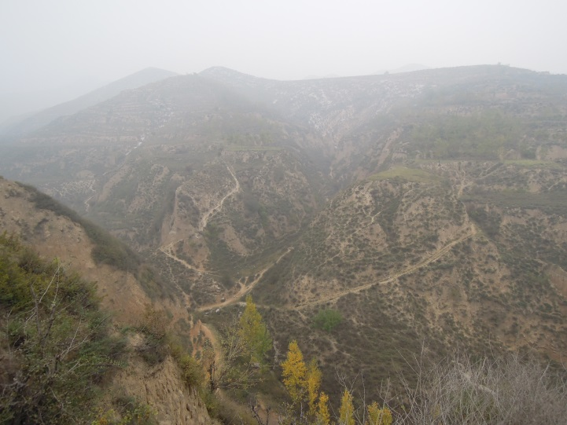 | 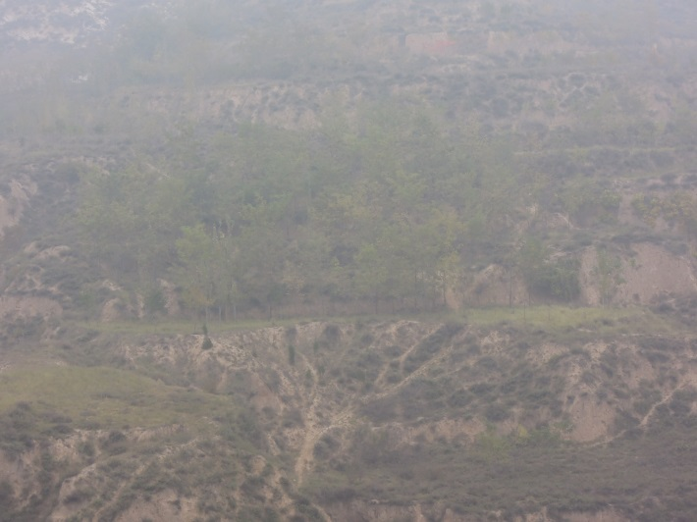

- The magazine of Hong Kong Literature has published two essays as documentary
reporting our plantation work as our cataract project in their recent publication. They will also donate about 30 copies for our keeping when the magazines are delivered to Hong Kong.

- FTI foundation had contacted Dr. Chong to add some more detail about the effect of their work in Shanxi and it was responded immediately and still waiting for further instruction from FTI.

Dr. Chong Hou Ming
3rd, November, 2014

